Patrolling Use cases:
P S limits IMP places tagged to be monitored.
Regularly visited by the police
Drawbacks
Not visiting blind spots and crime hot spots

Now 3 shifts
each shift one beat constable should visit atleast once in a day
should visit 30 meters radios
also make a note of any activity happens.
Should visit at a specific time only but not happening
Considering people movement and density
Also include events and festivals (shopping theaters zones)
SHO is having rights to over write plans
Imp locations like schools, colleges, banks, financial instructions, bars, theatres, shopping malls, crowded areas should be included and crime hotsoptes.
Include events and festivals major events, and dharnas etc.. can include as a suggestion.
News feed to suggestion to SHO. Improvement
Deviations at the time of visiting points also can be added.
Shift rotation calendar
Need website and mobile app.
Can input data by speaking, so can be converted to tedt and store after the confirmation.
Native to English conversion also.
Native to native
Actual audio log.
Report to SHO based on the inputs
Report on covered hotspot
Event vs offender details to monitor
Based on last month data it should suggest beat points and timings, SHO can make changes.

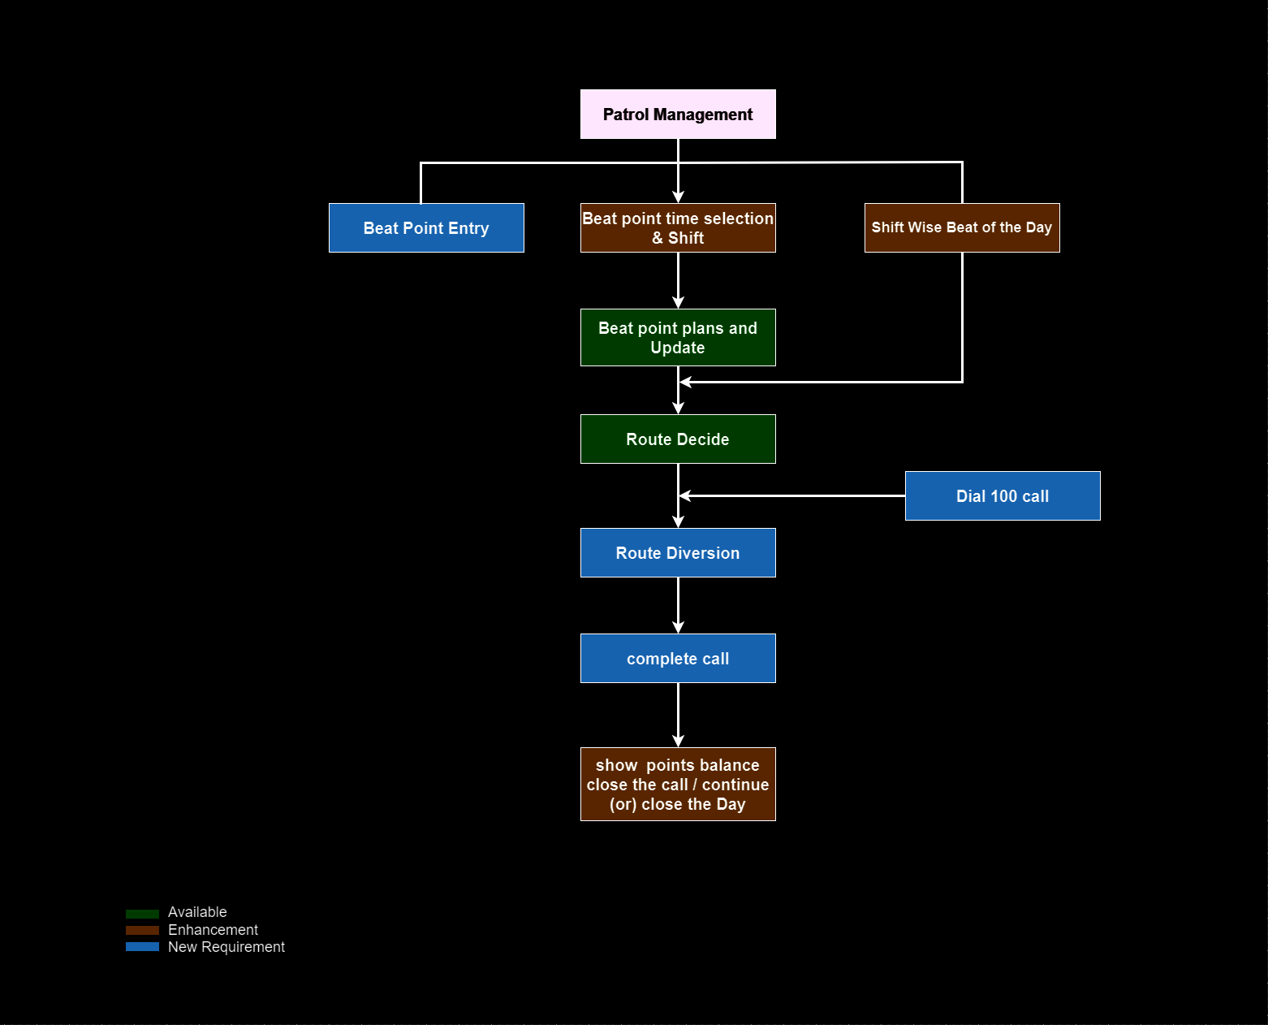

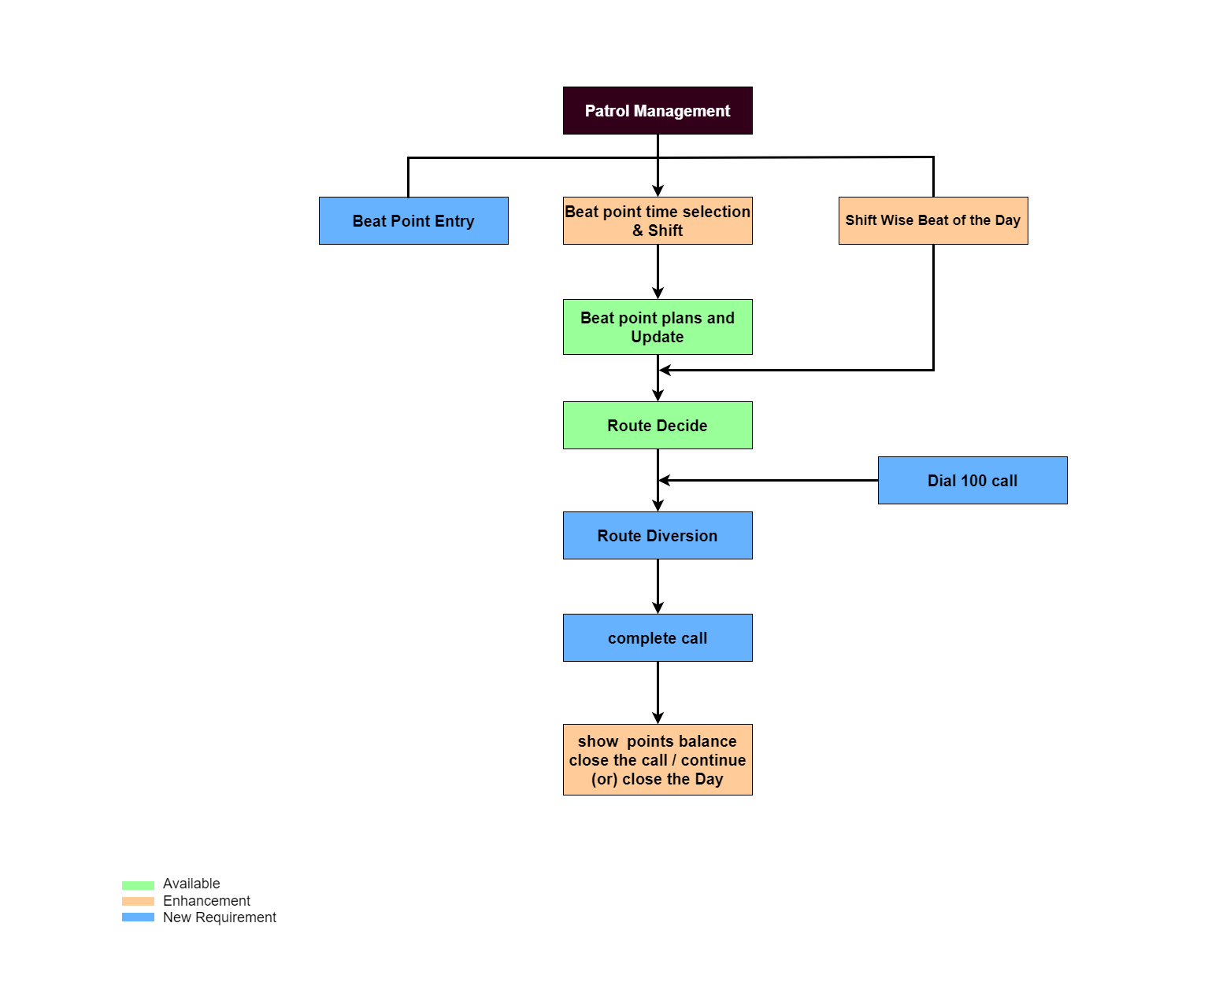

- Consider college
- Murder P1
- Robbery p2
- Other use cases

Need screens
Sample data set
Postgresql database
Dashboard

Police work in 3 shifts

1. Use Cases
Incident Priority Levels

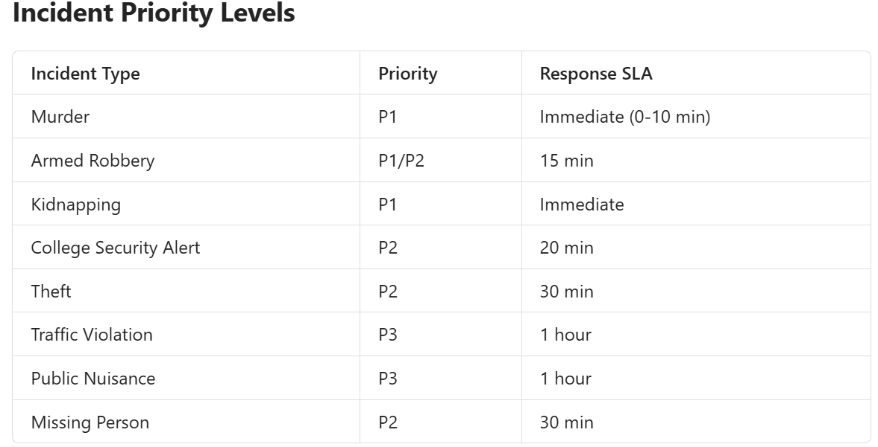

Advanced Police Command Dashboard
For a smart-city implementation, add:
- Live patrol GPS tracking
- Incident heatmap
- Nearest vehicle dispatch
- Shift attendance
- College geofencing
- SLA breach monitoring
- Crime analytics by area
- Response time analytics
- P1/P2/P3 trend charts
- AI-based hotspot prediction

Use Case 1: College Patrolling
Scenario
- Daily patrol near colleges.
- Suspicious activity reporting.
- Student safety monitoring.

Workflow:

Patrol Vehicle
↓
GPS Tracking
↓
College Area Monitoring
↓
Alert Raised
↓
Nearest Patrol Assigned
↓
Incident Closed
Murder (P1)
911/100 Call
↓
Control Room
↓
Nearest Patrol Assigned
↓
Investigation Officer Assigned
↓
Case Registration
↓
Closure
Robbery (P2)
Citizen Complaint
↓
Incident Created
↓
Patrol Dispatch
↓
Evidence Collection
↓
Case Investigation

Dashboard
Shows:
- Total Patrol Vehicles
- Active Incidents
- P1 Incidents
- P2 Incidents
- Officers On Duty
- Shift Wise Presence
- Incident Heat Map

Patrol Vehicle Screen
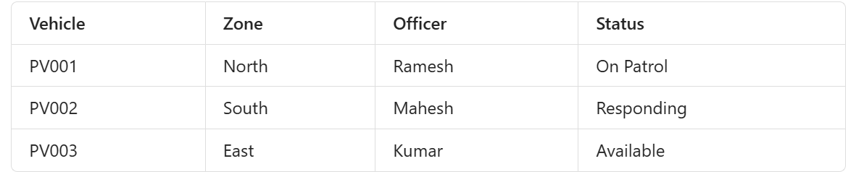
Incident Screen
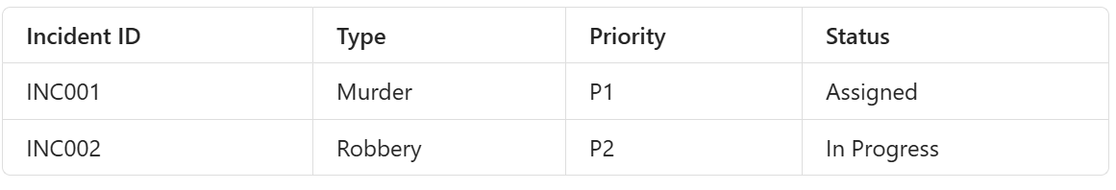
Officer Screen
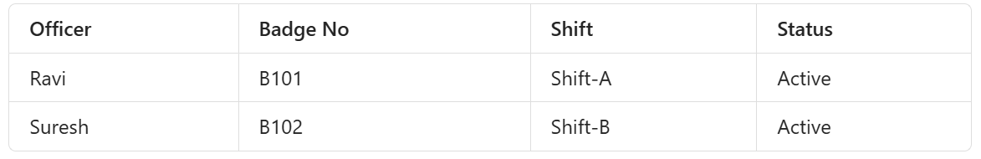
GIS Map Screen
Display
- Live Patrol Vehicles
- Incident Locations
- Hotspots
- Police Stations
- Colleges
Can use:
- OpenStreetMap
- Leaflet
- PostGIS

3. Police Shift Management
Shift A
06:00 AM - 02:00 PM
Shift B
02:00 PM - 10:00 PM
02:00 PM - 10:00 PM
Shift C
10:00 PM - 06:00 AM

Database stores:
shift_code
shift_start
shift_end

Officers
CREATE TABLE officers(
officer_id SERIAL PRIMARY KEY,
badge_no VARCHAR(20),
officer_name VARCHAR(100),
designation VARCHAR(50),
mobile VARCHAR(15),
shift_id INT
);

Shifts
CREATE TABLE shifts(
shift_id SERIAL PRIMARY KEY,
shift_name VARCHAR(20),
start_time TIME,
end_time TIME
);

Patrol Vehicles

CREATE TABLE patrol_vehicles(
vehicle_id SERIAL PRIMARY KEY,
vehicle_no VARCHAR(20),
zone VARCHAR(50),
officer_id INT,
status VARCHAR(30)
);

Incidents
CREATE TABLE incidents(
incident_id SERIAL PRIMARY KEY,
incident_type VARCHAR(100),
priority VARCHAR(5),
reported_time TIMESTAMP,
latitude NUMERIC,
longitude NUMERIC,
status VARCHAR(30),
assigned_vehicle INT
);

Colleges
CREATE TABLE colleges(
college_id SERIAL PRIMARY KEY,
college_name VARCHAR(200),
latitude NUMERIC,
longitude NUMERIC
);

Sample Data
INSERT INTO shifts
VALUES
(1,'SHIFT-A','06:00','14:00'),
(2,'SHIFT-B','14:00','22:00'),
(3,'SHIFT-C','22:00','06:00');

Officers
INSERT INTO officers
(badge_no,officer_name,designation,shift_id)
VALUES
('B101','Raj Kumar','Inspector',1),
('B102','Srinivas','SI',2),
('B103','Mahesh','Constable',3);

Vehicles
INSERT INTO patrol_vehicles
(vehicle_no,zone,status)
VALUES
('TS09PA1001','North','Available'),
('TS09PA1002','South','On Patrol'),
('TS09PA1003','West','Responding');

Incidents
INSERT INTO incidents
(
incident_type,
priority,
reported_time,
latitude,
longitude,
status
)
VALUES
('Murder','P1',NOW(),17.4435,78.3772,'Assigned'),
('Robbery','P2',NOW(),17.4465,78.3810,'Open'),
('College Security Alert','P2',
NOW(),17.4500,78.3900,'Open');

Dashboard KPIs
SELECT priority,count(*)
FROM incidents
GROUP BY priority;

Open Incidents
SELECT count(*)
FROM incidents
WHERE status='Open';

Patrol Utilization
SELECT status,count(*)
FROM patrol_vehicles
GROUP BY status;

Shift Manpower
SELECT
s.shift_name,
count(o.officer_id)
FROM officers o
JOIN shifts s
ON o.shift_id=s.shift_id
GROUP BY s.shift_name;

Recommended Tech Stack
Database
- PostgreSQL 18
- PostGIS Extension
Backend
- Spring Boot
- .NET 8
- Node.js
Frontend
- React
- Angular
Dashboard
- Apache Superset
- Grafana
- Power BI
Maps
- OpenStreetMap
- Leaflet
- Mapbox

